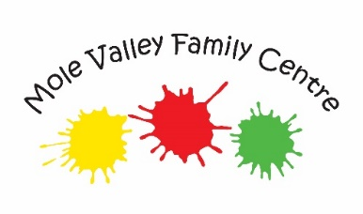
VACANCY
Part-time Outreach Worker (maternity cover)
We are looking to recruit an experienced family support practitioner to join our dynamic team of outreach workers.

The role will be based in our centre in Dorking and will include case holding level 3 families from across Mole Valley. You will also be working closely with the team to deliver a range of targeted services such as parenting courses.

Surrey Pay Grade S7, £27,991 - £30,510 FTE depending on experience
19 hours per week (worked across 3 days)
The role will start as soon as possible

Candidates must be car drivers and have a relevant background in early years, education and/or social care. They will have experience of working with children aged 0-12 years and their families
Closing date for application: 9am on Friday September 16th 2022
Interviews will be held on: Tuesday 20th September in the afternoon
For more information about the role please download the application pack from our website: https://www.molevalleyfamilycentre.co.uk/job-vacancies

To discuss the role further with the Family Centre Manager, please call 01306 740095 or 07956 958 784 to speak to Helen Sutherland.

Dorking Nursery School and Mole Valley Family Centre is committed to safeguarding and promoting the welfare of children, young people families and carers and expects all staff and volunteers to share this commitment Appointment to this post will be subject to an enhanced background checks by the Disclosure and Baring Service and satisfactory references

